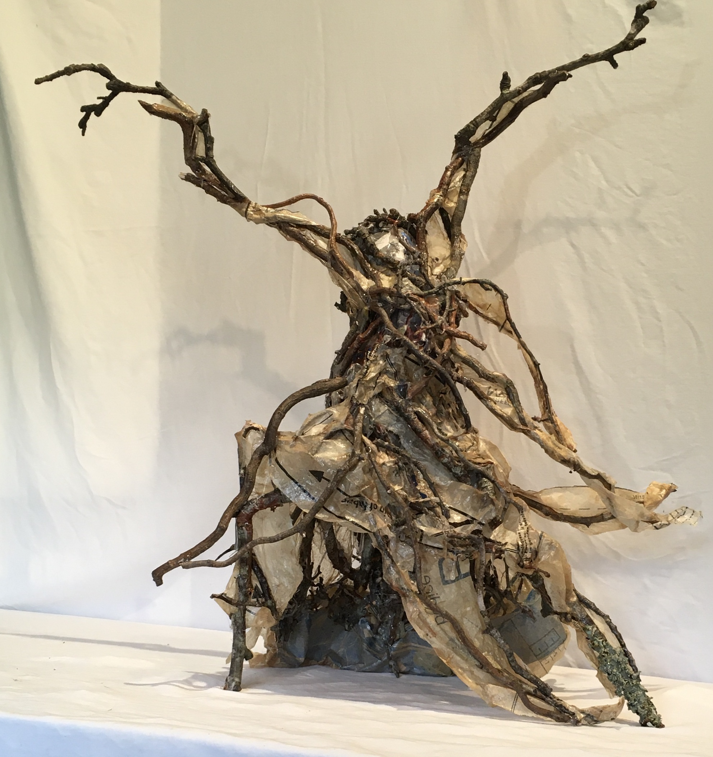Marianne DiNapoli-Mylet

DiNapoli-Mylet.com MDM-murals.com marioojart@gmail.com

STICKIT - Kaia -

**Artist Statement**

I am a multi-disciplinary artist, working in NC, I create drawings, mixed media pieces, sculptures and prints that investigate visual reflections of spiritual, societal, familial and experiential connections in my life.

My work is a dance of feminine arboreal forms in boldly emotive and gestural poses and may include traditional elements such as pastels and acrylics, as well as found and re-purposed objects such as sticks, Catholic medals and plastic onion bags. The resulting pieces, drawings, mixed media or sculptural all define space through fluidity, pattern, cadence and feminine magic gleaned from my immigrant, matriarchal forbears.

The visual narrative woven throughout my work is an articulation of supportive enclaves, powerful rhythmic gestures, strong feminine heritage, and the cathartic healing vitality of lyrical movement. Many pieces feature feminine forms as a trinity, signifying the trio of women in my nuclear family, my role as one of three sisters, and the three women who nurtured my formative years. This work delineates the power and observes the importance of women’s relationships as it validates and celebrates my heritage and cultural pride.